Quick Reference Guide - Students

Contents
Quick Reference Guide - Students 1
Announcements 2
Dismiss an Announcement 2
Subscribe to Announcements 2
Assignments 2
Submit File(s) (Figure 2) 2
View Feedback (Figure 3) 3
View Turnitin Feedback 3
View Submissions (Figure 4) 4
Calendar 4
Create a Task (Figure 5) 4
Classlist 5
Email Your Instructor or Classmates (Figure 6) 5
Content 5
Course Schedule 5
Bookmark Topics (Figure 7) 5
Download Topics or Content Modules (Figure 8) 6
Track Progress (Figure 9) 6
Search for Topic(s) 6
Organization & Personal Settings 7
Notifications (Figure 10) 7
Pin or Unpin Courses (Figure 11) 7
Profile 7
Pulse App 8
Discussions 8
Create a Discussion Thread (Figure 12) 8
Reply to Discussion Posts (Figure 13) 8
Subscribe to Discussions (Figure 14) 9
Grades 10
View Current Grade (Figure 15) 10
View Grade Feedback (Figure 16) 10
Save or Print Grades 10
Quizzes 10
Quiz Completion Screen (Figure 17) 11
Take a Quiz (Figure 18) 11
View Quiz Availability (Figure 19) 12
View Quiz Submission Results (Figure 20) 12

Announcements

Found on the course homepage. Subscribe or read instructor messages, course information, announcements, and updates.

Dismiss an Announcement (Figure 1)

- Select the 'X' next to an announcement heading to dismiss an announcement from your view

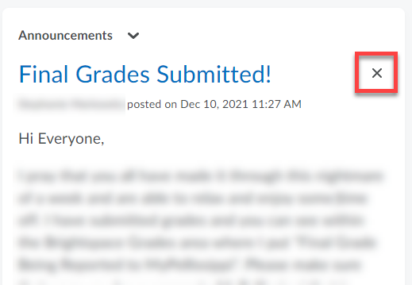
Figure 1 Dismiss Announcement

Subscribe to Announcements

- Receive announcements through text messages, phone notifications or by email. See Notifications in the sections below.

Assignments

Submit File(s) (Figure 2)

- Select the title of the assignment folder
- Review instructor directions or rubric
- Select 'Add a File | Upload'
- Select the file or multiple files (if enabled by the instructor)
- Select 'Add'
- Add optional 'Comments' to your instructor in the comment box
- Select 'Submit'

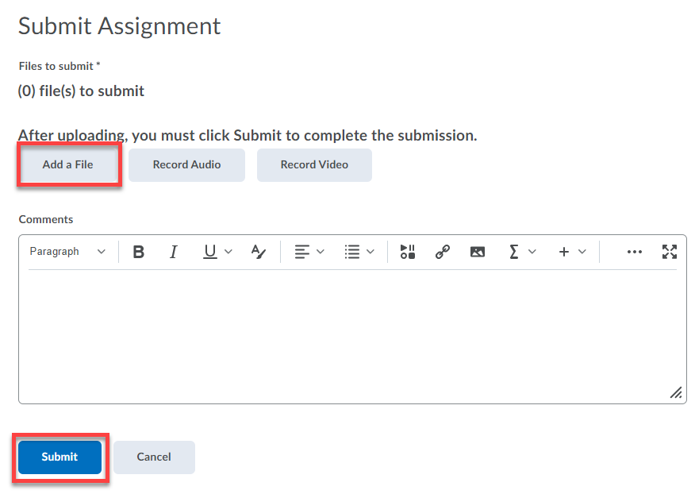
Figure 2 Submit Assignment

Note: Depending on the instructor's assignment settings, when another file is uploaded it may replace the previous file or it may add to the newly uploaded file

Tip: Supported File types: text documents (doc, docx, pdf, ppt) (not Apple iWork files), images (jpg, png, gif), media (mpeg, mp3, mp4, mov), web documents (htm, html)

Tip: There is not a file size limit, however, your computer may time out if you are uploading a very large file

View Feedback (Figure 3)

- Select the link under the 'Evaluation Status' column
- Review instructor feedback or download the attached feedback files the instructor has included

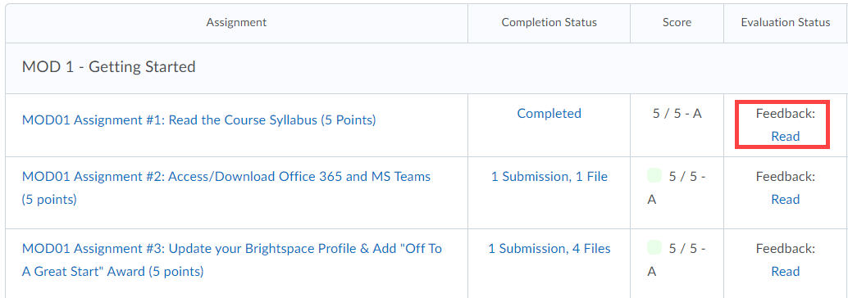
Figure 3 Read Assignment Feedback

View Turnitin Feedback

- If the instructor is using Turnitin, then the feedback may be in Turnitin's Feedback Studio
- Select the link under the 'Evaluation Status' column
- Click on the Turnitin similarity percentage number or select the 'Turnitin Grademark' icon

View Submissions (Figure 4)

- Click the link in the 'Completion Status' column next to the title of the assignment folder
- Click on a file name to download

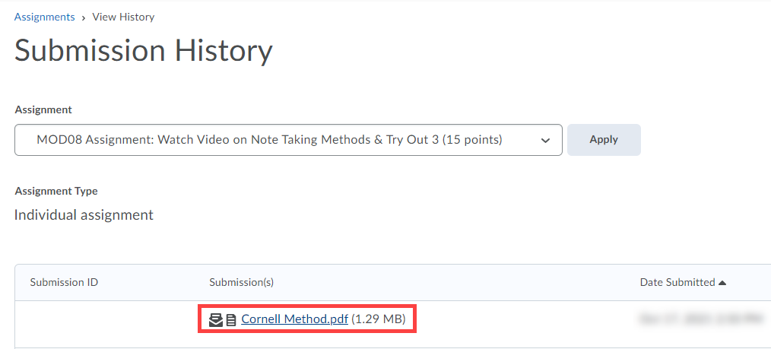
Figure 4 Submission History

Calendar

Found on the course navigation bar, course homepage, and the organization homepage.

Create a Task (Figure 5)

- Select Add a task...
- Type the task

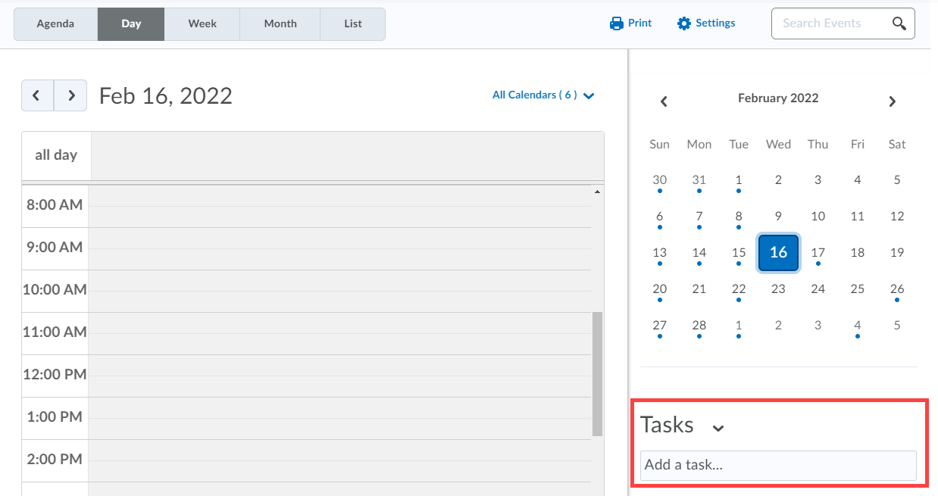
Figure 5 Add Calendar Task

Classlist

Email Your Instructor or Classmates (Figure 6)

- Click the checkbox next to the student(s) or instructor you want to email
- Select the 'Email' option at the top of the Classlist

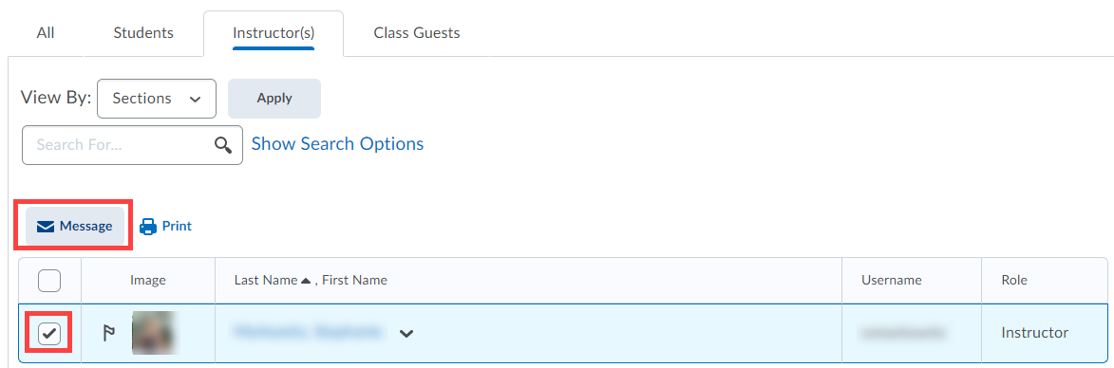
Figure 6 Email Instructor via Classlist

Content

Course Schedule

- Select 'Course Schedule' from the left navigation menu

Note: This will show upcoming due dates and activities in the course

Bookmark Topics (Figure 7)

- Select a topic
- Select the bookmark icon
- Review marked topics from the table of contents by selecting 'Bookmarks' from the left navigation menu

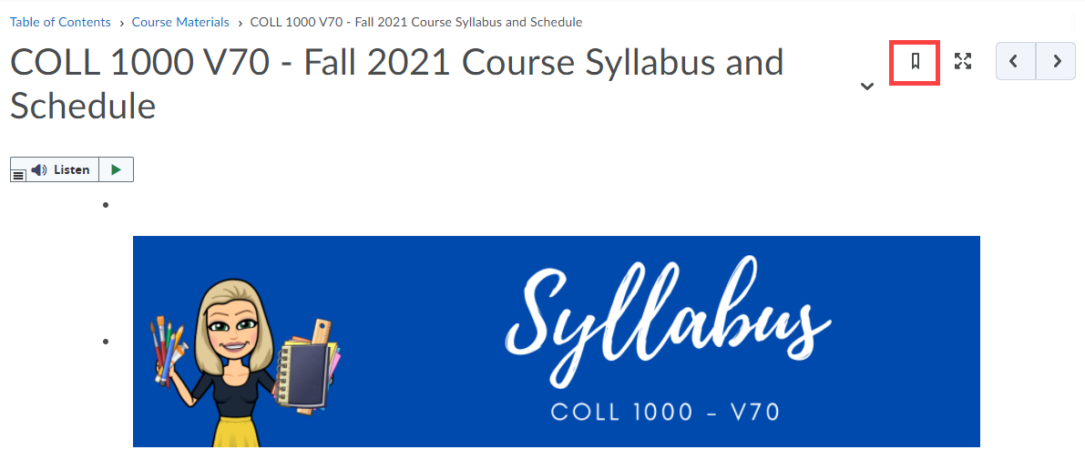
Figure 7 Bookmark Content

Download Topics or Content Modules (Figure 8)

- While viewing a topic, select the 'Download' button to download that topic
- While viewing a list of topics in a module, select the 'Download' button to download all topics in that module

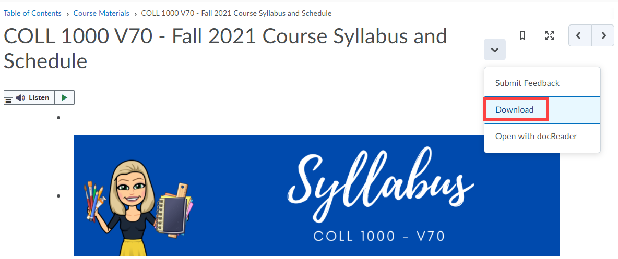
Figure 8 Download Content Module

Track Progress (Figure 9)

- Number counts will appear next to modules in the table of contents on the left of the content page, as well as a progress bar at the top of each module
- These numbers indicate topics that have not yet been viewed

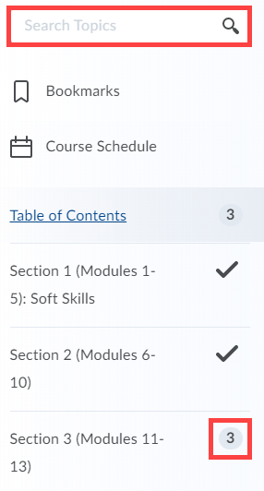
Figure 9 Track Progress

Search for Topic(s)

- Enter search criteria in the text-box at the top of the left navigation menu
- This searches topic titles and descriptions, but not the content within the topic

Organization & Personal Settings

Notifications (Figure 10)

- Find notification settings by selecting your name in the top-right corner of the page
- Click on 'Notifications'
- Enroll in Notifications to receive course updates via email or text message

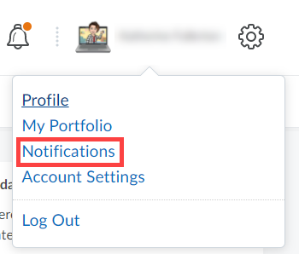
Figure 10 Notifications Settings

Pin or Unpin Courses (Error! Reference source not found.)

- Current courses should automatically appear in the 'My Courses' widget when you first log in. If they do not, follow these steps:
- Select the 'View All Courses' link at the bottom of the 'My Courses' widget on the Brightspace homepage
- Hover your mouse over the course image and select the option (...) icon
- Select 'Pin' to place the course near the top of your course list
- Select 'Unpin' to move the course toward the bottom of your list (or remove it completely from your view)
- Click the 'X' button to return to the Brightspace homepage
Note: You may also pin or unpin courses by using the 'Select a Course' menu (waffle icon) in the minibar at the top of the page. Simply click a 'Pin' icon next to a course title to pin or unpin.

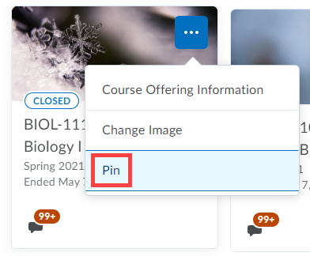
Figure 11 Pin a Course

Profile

- Select your name in the top-right corner of the page
- Add a profile picture (recommended) or further contact information to share with your instructor and classmates (optional)

Pulse App

- View course updates, content, dates, announcements, and grades for all courses
- Download the app for iPhone and Android devices. Download the Pulse App

Discussions

Create a Discussion Thread (Error! Reference source not found.)

- Click into a forum topic
- Select the 'Start a New Thread' button
- Enter a subject and desired content: text, images, media, video, tables, attachments, etc.

Note: Some instructors will require a thread to be created before you can see other student responses in a thread.
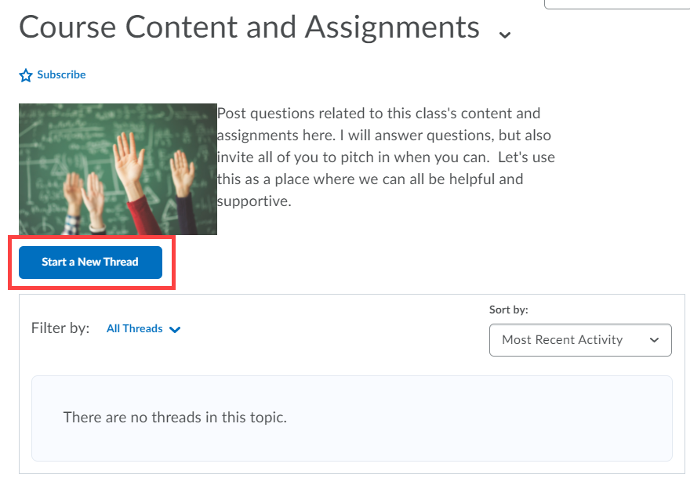
Figure 12 Start Discussion Thread

Reply to Discussion Posts (Figure 13)

- Access the forum thread by clicking into a thread of choice
- Select the 'Reply to Thread' button
- Enter a subject and desired content: text, images, media, video, tables, attachments, etc.

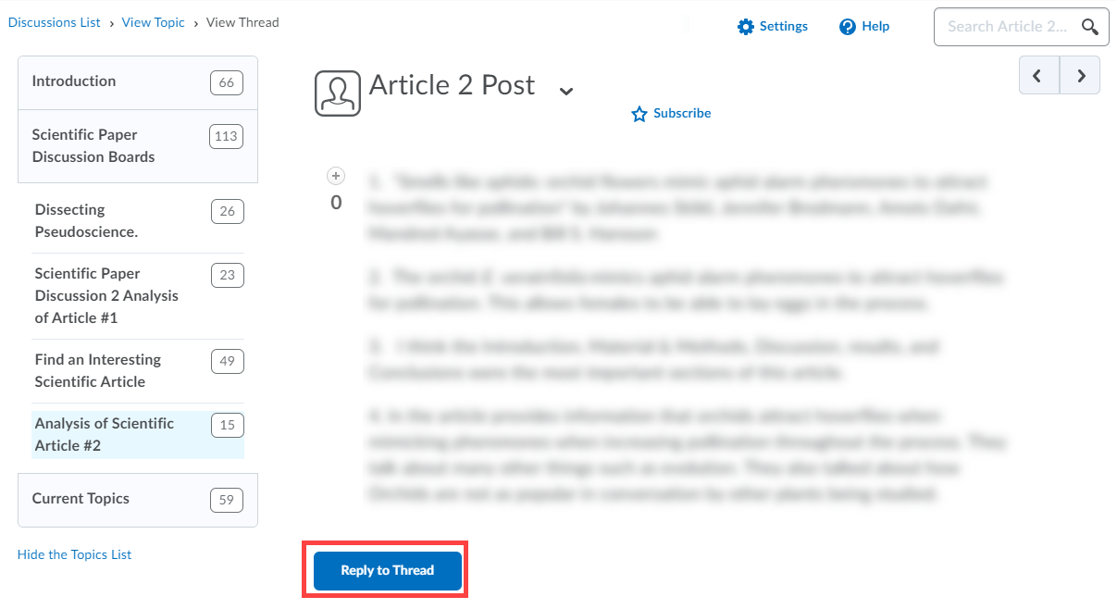
Figure 13 Reply to Discussion
Note: Some instructors will require a thread to be created before you can see other student responses in a thread.

Subscribe to Discussions (Figure 14)

- Receive updates via text message, phone notifications, or email. See Pulse App and Notifications
- When you post, by default a checkbox will be selected to 'Subscribe to this thread'
- To subscribe to any discussion, click the 'Star' icon 'Subscribe' link

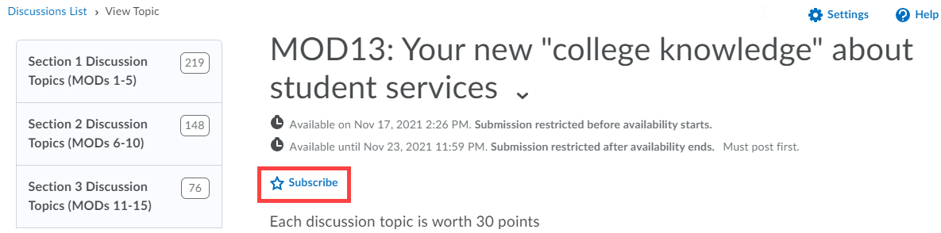
Figure 14 Subscribe to Discusison Thread

Grades

View Current Grade (Figure 15)

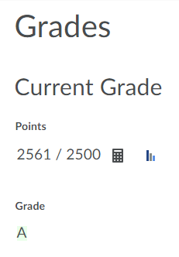
- Current running grades will be totaled and visible at the top of the grade book page above the grade items. It will be listed as 'Final Calculated Grade' (even if your grade isn't truly final yet)
Figure 15 Current Grade
- This grade is only visible when the instructor releases it
- If it is not visible, please contact your instructor
- Further grade information is also available in 'Class Progress' in the navbar

Note: Click the calculator icon next to your point total to see how your grade was calculated

View Grade Feedback (Figure 16)

- If an instructor has included a feedback comment with the grade item, then it will appear in the 'Feedback' column on the grades page
- Rubrics, grade averages, and distribution statistics will appear as an icon next to the grade item title if the instructor has made them available

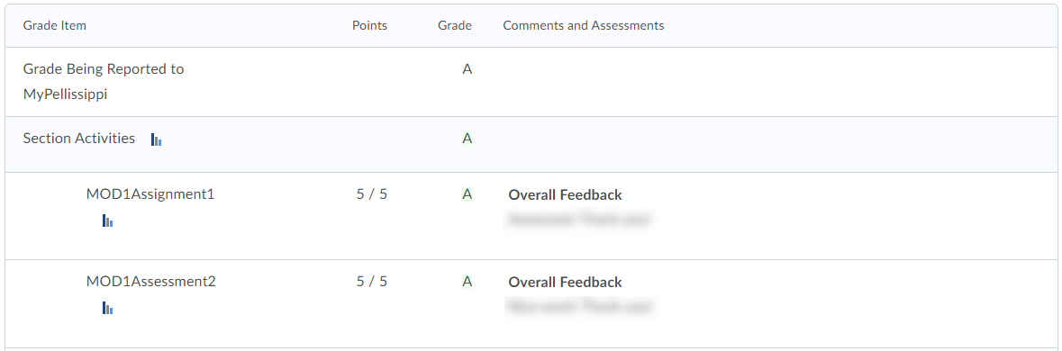
Figure 16 View Grade Feedback

Tip: You may need to go into a course tool itself to see some feedback. See the section on Assignments and Quizzes for more information.

Save or Print Grades

- Select 'Print' in the top-right corner of the grades page
- Choose a printer or export to a PDF file

Quizzes

Quiz Completion Screen (Figure 17)

- After submitting a completed quiz, the score may be available immediately on the quiz completion screen
- The score may be inaccurate if the quiz contained short answer or essay questions, which are not automatically graded
- The instructor will grade these manually and the score will be adjusted

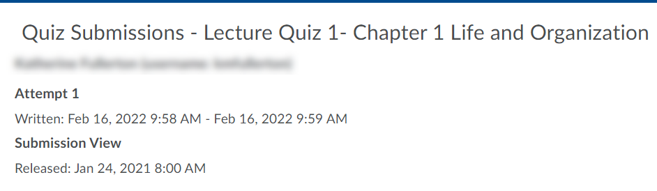
Figure 17 Quiz Submission Page

Note: Your instructor controls if you can see the correct/incorrect answers on a quiz after you completed it. Contact your instructor if you have questions.

Take a Quiz (Figure 18)

- Select the title of the quiz
- Review the quiz description, time and attempts allowed
- Click the 'Start Quiz' button
- Select 'Submit Quiz' when finished

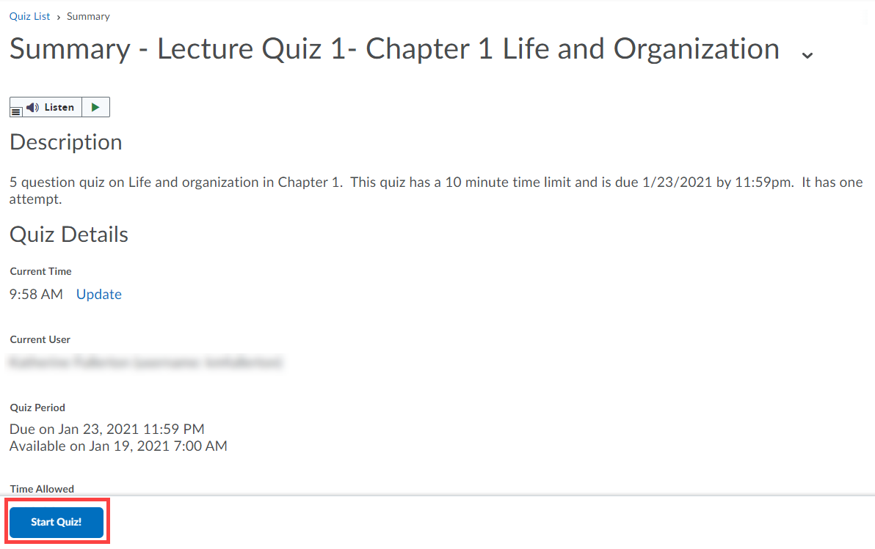
Figure 18 Start a Quiz

Note: Quiz answers save automatically, so if you run into a technical issue, you should not lose your progress. However, you have to contact your instructor if your attempt gets stuck or you need additional time/attempts.

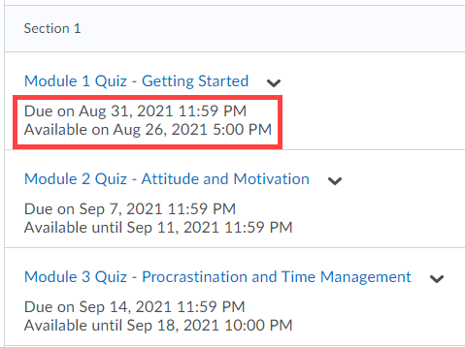
View Quiz Availability (Figure 19)
Figure 19 Quiz Availability

- The list of quizzes will display with start and end dates of availability (if enabled by the instructor)
- Alternatively, an 'Always Available' message will appear with the quiz title

View Quiz Submission Results (Figure 20)

- Select the dropdown arrow next to the title of a quiz
- Select 'Submissions'
- Select the attempt from the 'Individual Attempts' column
- Review score(s) and question feedback and answers (if enabled by the instructor)
- Score and feedback may also have been sent to Grades

Figure 20 Quiz Submissions

Note: Your instructor controls if you can see the correct/incorrect answers on a quiz after you completed it. Contact your instructor if you have questions.

Created by PSTCC Distance Education

